COBIT 2019 Compliance for Log360
Strengthen cybersecurity and meet COBIT 2019 compliance with Log360.
Region: International | Type: Industry Standard | Category: Compliance | Pricing: Free

Overview
The COBIT 2019 compliance extension in Log360 helps organizations meet COBIT 2019, the enterprise IT governance and management framework from ISACA adopted globally to govern IT resources, manage risk, and assure regulatory compliance by providing centralized log management, audit trail collection, and configuration change monitoring. The platform supports COBIT 2019 requirements for governance evaluation and direction, strategic IT planning, change and configuration management, service delivery and operations, access and identity management, and continuous performance monitoring.
For Governance Evaluation, Direction, and Monitoring (EDM), Log360 captures AD logon activity, GPO changes, policy modifications, and audit event logs to provide the governance evidence trail required by EDM objectives. To address Align, Plan, and Organize (APO), the platform monitors policy changes, network device configurations, user account changes, and group modifications to validate alignment of IT resources with organizational strategies and risk policies. The extension also supports Build, Acquire, and Implement (BAI) by providing capabilities that tracks registry changes, system events, process activity, software updates, and backup/restore operations to demonstrate controlled build and implementation processes.

Key Features
- Deliver, Service, and Support (DSS): Log360 monitors backup and disaster recovery operations, cloud storage security incidents, and malware detection events to support operational service assurance and continuity obligations.
- Monitor, Evaluate, and Assess (MEA): Log360 collects event logs, system events, GPO changes, process tracking, and database audit trails to generate continuous monitoring evidence required for MEA compliance assessments.
- Governance Evaluation, Direction, and Monitoring (EDM): Log360 captures AD logon activity, GPO changes, policy modifications, and audit event logs to provide the governance evidence trail required by EDM objectives.
- Align, Plan, and Organize (APO): Log360 monitors policy changes, network device configurations, user account changes, and group modifications to validate alignment of IT resources with organizational strategies and risk policies.

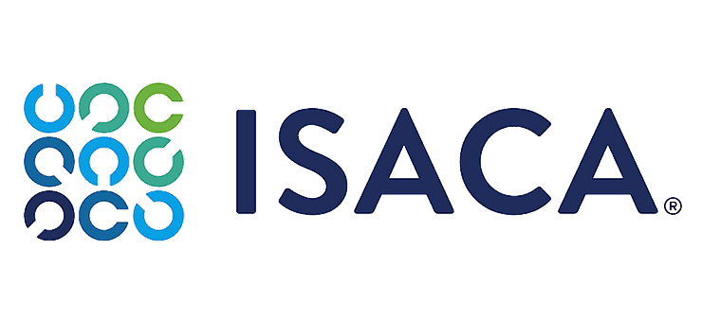
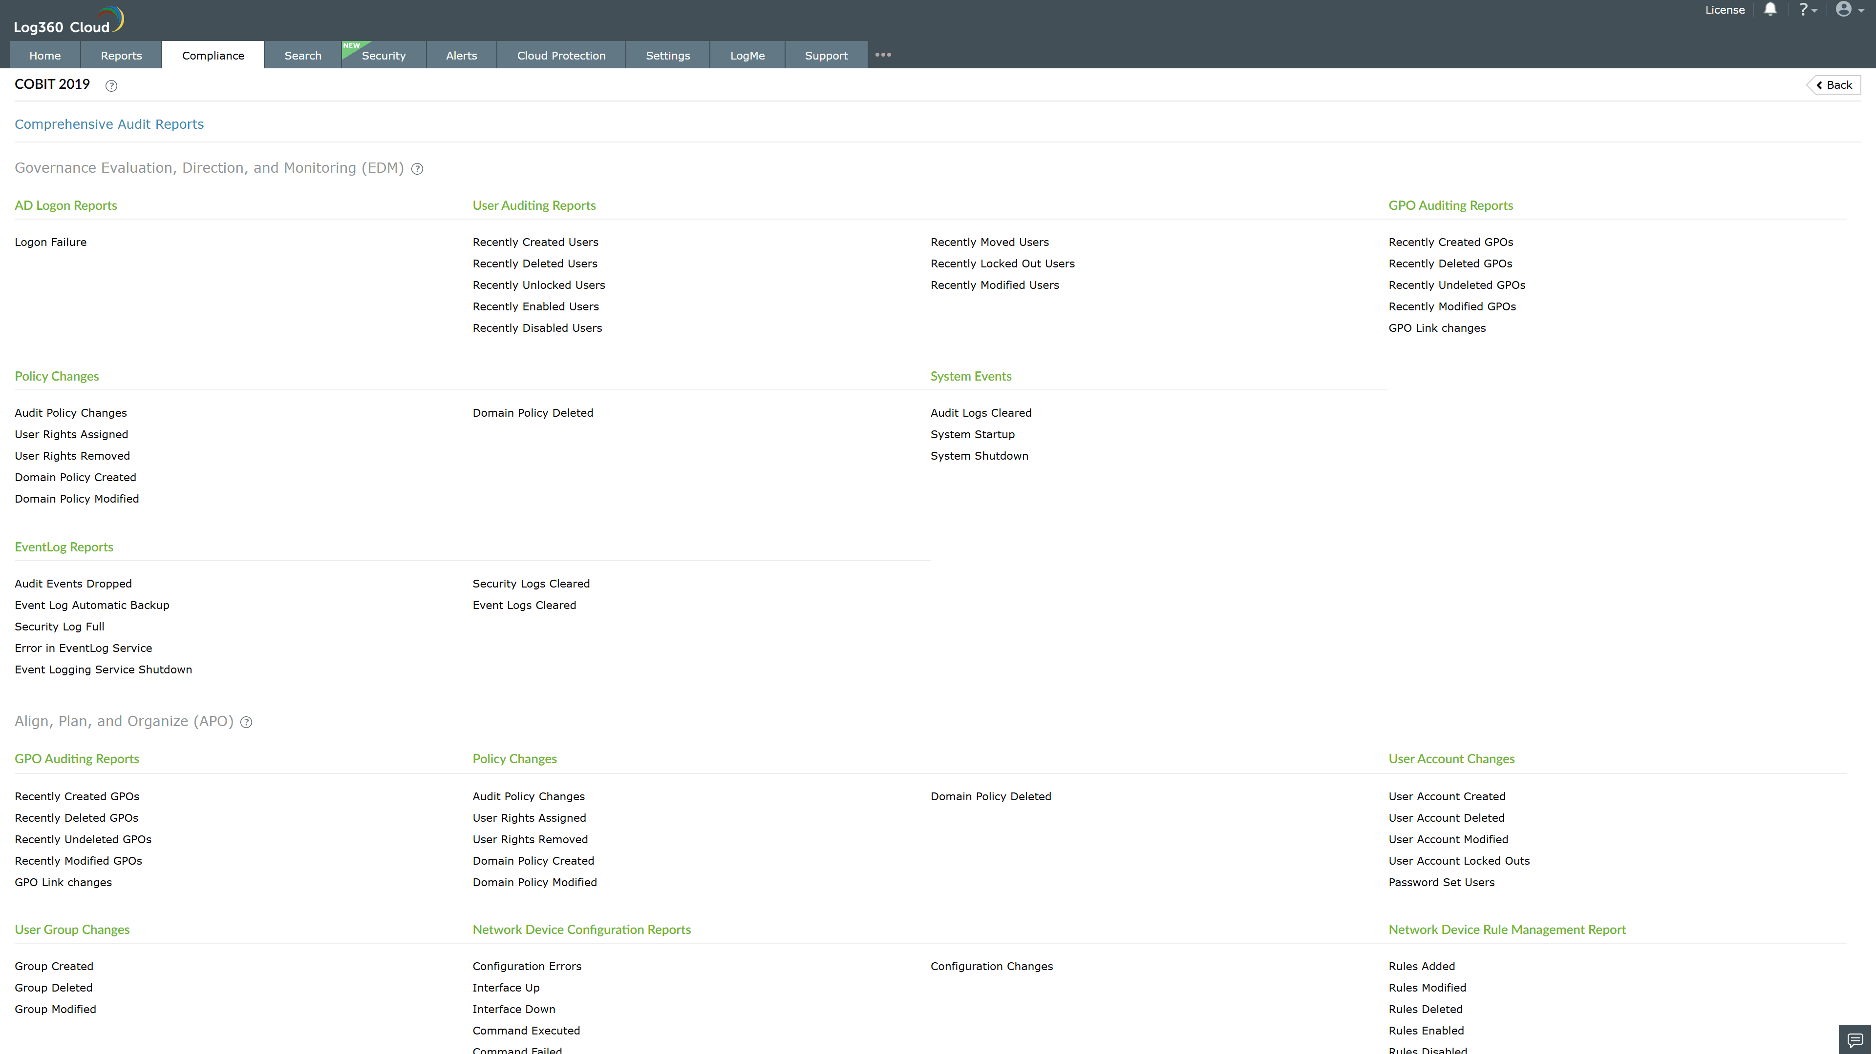
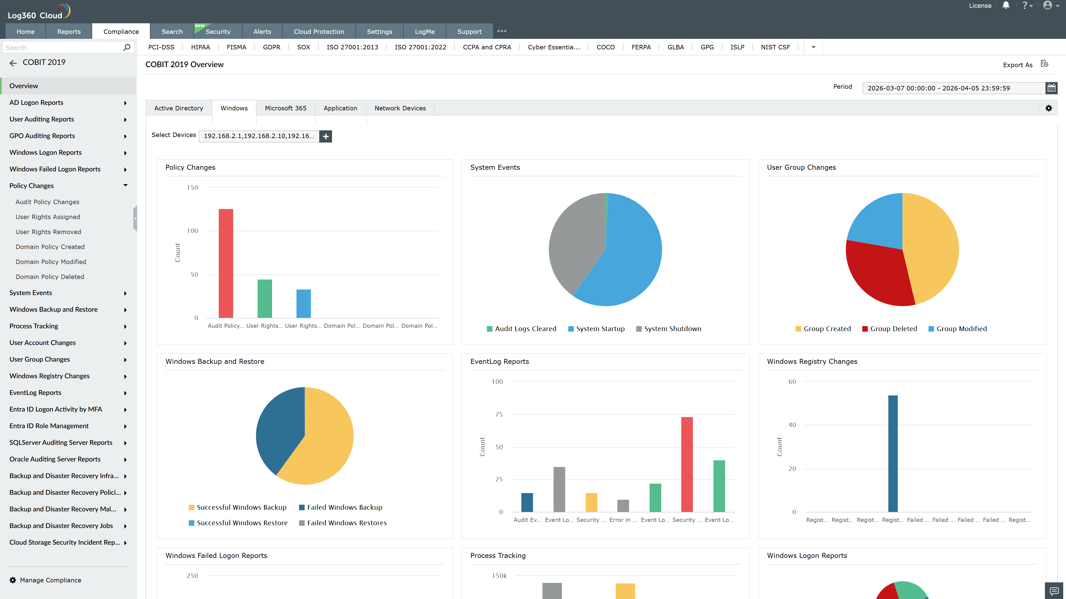
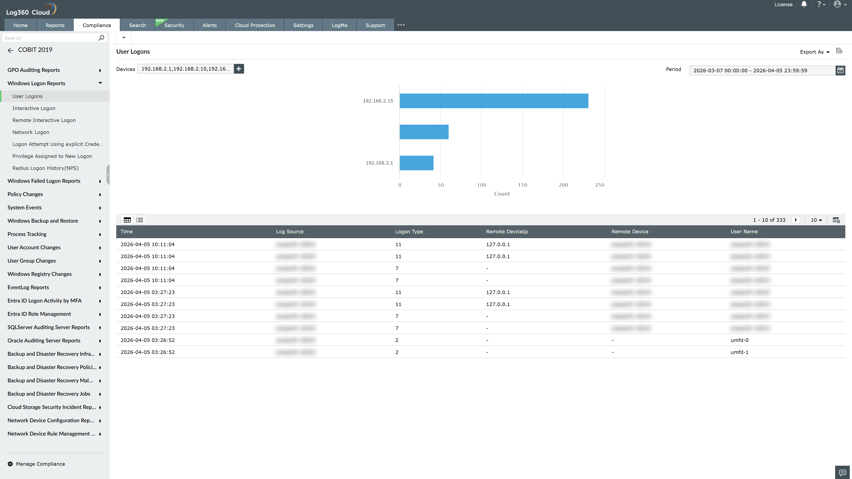
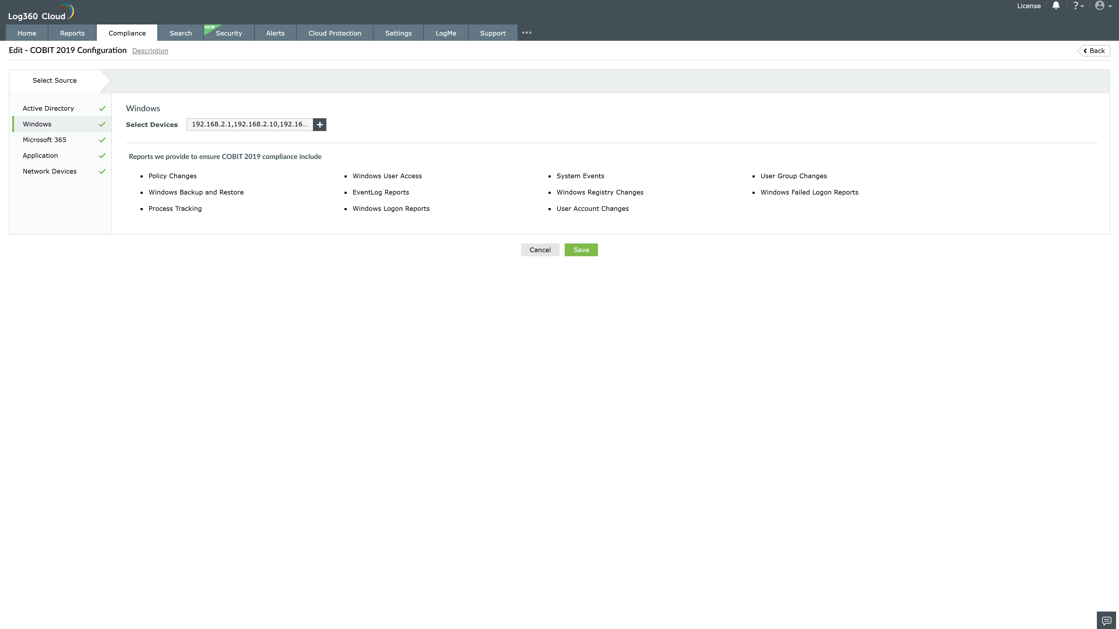
Valid Submission : Yes
Supported Editions : Free, Basic, Standard, Professional, MSSP
Help Document : https://www.manageengine.com/log-management/help/integrations/compliance-extensions.html
Help Video : Not provided
Tags : Log360, Compliance, Privacy monitoring, Data privacy, Regulatory compliance
Supported DCs : US, IN, JP, CA, AU, UK and EU
Privacy Policy:
Terms of Service:
Release Notes:
Predefined reports for the COBIT 2019.

